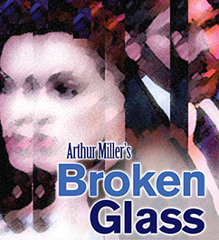

PRESS CONTACT:
Nancy Richards – 917-873-6389 (cell)/nancy@northcoastrep.org
MEDIA PAGE: www.northcoastrep.org/press
PHOTOS BY: Aaron Rumley

FOR IMMEDIATE RELEASE, PLEASE:

NORTH COAST REPERTORY THEATRE PRESENTS :
BROKEN GLASS BY ARTHUR MILLER
Performances begin Wednesday, October 16th,
with Opening Night Saturday, October 19th at 8pm
Running Through November 10th, 2013
At North Coast Repertory Theatre
Directed by Rosina Reynolds

This production is sponsored by the generosity of Lee & Frank Goldberg

San Diego, October 7, 2013 - San Diego’s professional premiere of Arthur Miller’s Olivier award-wining drama BROKEN GLASS takes place in Brooklyn in 1938. The master dramatist weaves a gripping mystery of guilt, personal tragedy and love. The complex personal relationships along with a plot filled with arresting incidents leads us through an examination of the playwright’s moral vision which ultimately delivers us to the poignant and dramatic conclusion. A must-see for the serious theatre lover.

North Coast Rep’s Artistic Director David Ellenstein* will be featured in the cast along with Ralph Elias*, John Herzog*, Kerry McCue*; Elaine Rivkin* and Shana Wride*; Musician, Melissa Chu (Cello). The designers for BROKEN GLASS include: Marty Burnett (Set Designer), Matt Novotny (Lighting Designer), Alina Bokovikova (Costume Designer), David Medina (Props & Set Dressing); and Aaron Rumley* (Stage Manager).

*The actor or stage manager appears through the courtesy of Actors’ Equity Association, the union of professional actors and stage managers in the United States

BROKEN GLASS previews begin Wednesday, October 16th; Opening Night on Saturday, October 19th at 8pm includes a post-show reception. A special talkback on October 25th with the cast and director. It will play Wednesdays at 7pm, Thursdays through Saturdays at 8pm, Saturdays and Sundays matinee at 2pm with Sundays at 7pm, through November 10, 2013. (See Schedule below.) North Coast Repertory Theatre is located at 987 Lomas Santa Fe Drive, Ste D, Solana Beach, CA 92075. Tickets: Opening Night - $54, Previews- $37; Week Nights - $41; Sat. Eve. & Sun. Mat.- $48; Sat. Mat. & Sun. Night - $41. Seniors, Students, Military - $3 off admission. Call 858-481-1055 or visit www.northcoastrep.org to purchase tickets.

For background information and photos, go to www.northcoastrep.org/press.

Please follow North Coast Repertory Theatre on social media as well on Facebook at https://www.facebook.com/pages/North-Coast-Rep/128553240497901
Twitter: https://twitter.com/NorthCoastRep
YouTube: http://www.youtube.com/user/NCRTheatre?ob=0

Busy director Rosina Reynolds and her cast members are available for interviews by phone, in person, and in-studio. For more information and to arrange interviews or press tickets, please contact Nancy Richards at nancy@northcoastrep.org, or 917-873-6389 cell.

FACT SHEET

WHAT: NORTH COAST REPERTORY THEATRE presents BROKEN GLASS
Written by Arthur Miller
Directed by Rosina Reynolds
Cast: Ralph Elias, David Ellenstein*, John Herzog*, Kerry McCue*, Elaine Rivkin* and Shana Wride*,

WHERE: NORTH COAST REPERTORY THEATRE
987 Lomas Santa Fe Drive, Ste D
Solana Beach, CA

SCHEDULE*: Previews: October 16- October 18, 2013
Opens: October 19 @ 8pm
Closes: November 10, 2013
Wed. @ 7pm, Thurs-Sat @ 8PM; Sat & Sun @ 2PM, Sun @7pm
Talkback with cast & director: October 25
*Schedule Varies

PRICES: Previews $37.00
Opening Night $54.00
Week Nights $44.00
Sat. Matinees & Sunday Nights $41.00
Sat. Nights & Sunday Matinees $48.00

DISCOUNTS: Seniors, Students, Military $3.00 admission

BOX OFFICE (858) 481-1055 or www.northcoastrep.org

OCTOBER
M | T | W | T | F | S | S
13 | 15 | 16  8pm | 17  8pm | 18  8pm | 19  Opening Night 8pm | 20  2pm & 7pm
21 | 22 | 23  7pm | 24  8pm | 25  8pm  Talkback | 26  2pm & 8pm | 27  2pm & 7pm

NOV
M | T | W | T | F | S | S
28 | 29 | Oct 30  7pm | Oct 31  8pm | Nov 1  8pm | 2  2pm & 8pm | 3  2pm & 7pm
4 | 5 | 6  7pm | 7  8pm | 8  8pm | 9  2pm & 8pm | 10  2pm  Closing

BACKGROUND:

North Coast Repertory Theatre 2013-2014 -Season 32 runs September 4, 2013 through August 3, 2014. The next production is the world premiere, THE HUMBUG’S HOLIDAY SPECTACULAR conceived, written and performed by Phil Johnson and Omri Schein , Songs by Omri Schein and James Olmstead December 11 - December 28, 2013. The new year will greet with a date night play, WHO AM I THIS TIME? (And Other Conundrums of Love) By Aaron Posner, Adapted from the short stories by Kurt Vonnegut, directed by Andrew Barnicle, January 8 – February 2, 2014. This work is full of charm, magic and heart. Down a well-worn path, hand-in-hand, take a walk…through leaves and over bridges, breathe in the soul’s seductive moments through three love stories set in mythological small-town America. Along the circuitous course of love, we travel with our new friends hoping to catch a genuine glimpse of humankind’s most elusive sentiment. Up next is THE SCHOOL FOR LIES by David Ives, Adapted from Moliere’s The Misanthrope, directed by Andrew Paul beginning on February 19 to March 16. Molière’s wit meets its match in this saucy, scintillating new adaptation. Tony Award nominee David Ives’ deliciously off-color tribute to THE MISANTHROPE stuffs a seventeenth-century farce full of contemporary slang—with results worthy of a Baroque vaudeville show. Amid a glittering world of gossip, glamour and scandal, a gaggle of misbehaving characters chatter away in hilarious rhyming couplets. A world premiere, MANDATE MEMORIES, follows on April 9 to May 4. In this taut and witty drama filled with revelations of love affairs, dreams and the founding of Israel, layers are peeled away to reveal the deep hearts of two caring and compassionate human beings. There is a mysterious connection between Gustav Frolich, an eighty-year-old Holocaust survivor and Jane Stirling, a sixty-two year-old English widow as their debate reveals how different and yet how similar they are. By the author of HALPERN AND JOHNSON, Lionel Goldstein once again takes us deep into the hearts of two fascinating characters. Our second world premiere of the season, FADED GLORY opens on May 28 – June 22. Meet Daniel Sickles, a 19th-century congressman, friend to presidents, Civil War general, lover of Queen Isabella of Spain, notorious philanderer, embezzler, murderer, and the officer who almost cost the Union victory in perhaps the most pivotal battle of the Civil War only to receive the Congressional Medal of honor. Based on this real figure from American history, funny, poignant and filled with astonishing little-known historical information, FADED GLORY promises to be a highlight of our season. A rollicking comedic romp through this amazing life. The season will end with ROMANCE/ROMANCE beginning on July 9 to August 3. Frothy and fun, this musical reminds us of those secret, frivolous, and embarrassing romantic impulses to which we are susceptible. In this rousing two act musical we take a varied look at romance seekers in two ways: from a delightful romp through the sexual ennui of the turn of the century Vienna in the first act, to a second act modern look at affection and disaffection in summer house in the Hamptons. An Off-Broadway sensation that successfully moved to Broadway, ROMANCE/ROMANCE is a sweetheart of a musical perfect for North Coast Rep’s intimate stage.

About the North Coast Repertory Theatre:
North Coast Repertory Theatre is a professional Equity theatre founded in 1982 by Olive and Tom Blakistone. Currently celebrating its 32nd season, North Coast Rep has received critical acclaim from media and audiences alike, and has evolved into one of the area’s leading performing arts organizations. North Coast Rep prides itself on employing the majority of its actors from Actors’ Equity Association for its high quality, award-winning productions, and staging works by established and emerging playwrights. Throughout its history, North Coast Rep has created a platform where artist and audience thrive through the intimacy of live theatre, recognizing the power of theatre to challenge complacency, revitalize the imagination, nurture the unexpected and embrace the variety and diversity in our lives.
#####

BIOS

Arthur Miller (Playwright) was born in New York in 1915. During his lifetime, Miller amassed numerous awards, including three Tony Awards, A Tony Lifetime Achievement Award, two Emmy Awards, the Peabody Award, and the Pulitzer Prize. Among his critically acclaimed plays are All My Sons; Death of a Salesman, A View from the Bridge; and After the Fall. Miller was often in the public eye, appearing before the House Un-American Committee, where he refused to name names. He likened the hearings to the Salem Witch trials, the impetus for his most performed play, The Crucible. His brief marriage to screen icon Marilyn Monroe fascinated the public and brought unwanted publicity to the scholarly author. Miller died in 2005.

Rosina Reynolds (Director) North Coast Repertory Theatre: Educating Rita; Glorious; Don’t Dress For Dinner; Relatively Speaking; Importance of Being Earnest; Travesties; An American Daughter; The Sum of Us; Blithe Spirit; Corpse; Rough Crossing; Chekov in Yalta. San Diego Repertory Theatre: Bad Dates. Cygnet Theatre: Atwater; Fixin’ to Die. Renaissance Theatre: Caretaker (San Diego Critics Circle Award). Compass Theatre: Three Days of Rain. Fritz Theatre: Vigil. Hahn Cosmopolitan Theatre: Marvin’s Room. Diversionary Theatre: Happy Endings are Extra; Twilight of the Golds; Beautiful Thing; Wrinkles; Another American; Asking and Telling; Gross Indecency: The Three Trials of Oscar Wilde; Breaking The Code; Lot’s Daughters.

The Cast:

Ralph Elias*(Phillip Gellberg) has acted on regional theatre stages and Off-Broadway, as well as having directed 32 professional productions. In 2008, he won critical plaudits for his performance in North Coast Rep’s A Shayna Maidel. And appeared in the world premiere of Rocket City, directed by David Ellenstein at the Alabama Shakespeare Festival. He had previously directed David in NCRT’s successful 2003 production of Donald Margulies’ Sight Unseen. Regional credits include the Old Globe Theatre’s American premiere of Alan Ayckbourn's Mr. A's Amazing Maze Plays, Edward Albee’s The Goat, or Who Is Sylvia? at the San Diego Rep, and playing every character other than Lynn Cohen’s Emma Goldman at Indiana Repertory Theatre. He performed opposite Dianne Wiest in The Dybbuk and with Robert Prosky in Death of a Salesman at Washington’s Arena Stage, and has acted at Maryland Shakespeare Festival, Blackfriars Theatre, Equity Library Theatre, The Open Space Theatre and Trinity Repertory Theatre. From 1988 to 1995, Mr. Elias was artistic director of Blackfriars Theatre, described as "a San Diego treasure" by the city's Commission for Arts and Culture. His innovative production of I. B. Singer’s Teibele and Her Demon won an array of San Diego Critics Circle and Drama-Logue awards; among several similarly acclaimed shows were John Patrick Shanley’s Danny and the Deep Blue Sea and Sam Shepard’s The Unseen Hand. His unique staging of Beth Henley’s Abundance became the first American production ever seen in Far-Eastern Russia, where he has since directed four productions for the Maxim Gorky Theatre of Vladivostok, including Shakespeare’s Romeo and Juliet in 2005. Broken Glass marks Ralph’s return to theatre after five years as caregiver for his wife Allison, to whom his performance is dedicated.

Elaine Rivkin* (Sylvia Gellberg) is returning to North Coast Rep after playing Sarah in last season’s The Lover. Most recently, she played Mrs. Clandon in Shaw’s You Never Can Tell with Remy Bumppo Theatre in her hometown, Chicago. Other Chicago credits: Pyretown and Tree (Victory Gardens); Picasso at the Lapin Agile, Libra and The Crucible (Steppenwolf); The Cider House Rules, The Homecoming, Conquest of the South Pole, Hushabye Mountain, Pride’s Crossing, Beautiful Thing, Speaking in Tongues, Remembrance, Mann Ist Mann, Salt of the Earth, Hellcab and many others (Famous Door); ‘Night Mother (Hancock Productions); Execution of Justice (About Face); St. Colm’s Inch (Chicago Dramatists); La Bete (Pegasus). Outside Chicago: Hellcab (Singapore Arts Fest); The Early Girl (Edinburgh Fringe Fest). Film: In the Name of God; Punched in the Gut; 684 Brewster; and Living in the Edge. Elaine is a proud member of SAG-AFTRA and AEA.

David Ellenstein* (Dr. Hyman) In thirty five years as a proud member of Actors’ Equity Association, David has acted in more than 100 productions at theatres from coast to coast. Highlights include the title roles in Hamlet at the Los Angeles Repertory Company and RICHARD III at California Shakespeare Festival, “Calisto” in The Illusion and “Harker”in Dracula at the Arizona Theatre Company, “Stanley” in Broadway Bound at the Alaska Rep and Gaslamp Quarter Theatre, “Chrysale” in Learned Ladies and Editor Webb in Our Town at Theatricum Botanicum, “Tevye” in Fiddler On The Roof at Moonlight Stages, and “Waxman” in Sight Unseen, “Matt” in Talley’s Folly and “Kahn” in My Name Is Asher Lev right here at North Coast Rep where David has served as Artistic Director since 2003. Acting credits include over three dozen film and television appearances.

Shana Wride*(Margaret Hyman) has worked both locally and regionally as an actor and director. She was last seen many years ago at North Coast Rep in The Hasty Heart. Other acting credits include Cygnet Theatre’s production of Private Lives (Craig Noel Critic’s Circle Award); San Diego Repertory Theatre: Women Who Steal, A Christmas Carol, Suds, Working, Six Women with Brain Death; Diversionary Theatre: The Further Adventures of Hedda Gabler, Next Fall; Sledgehammer Theatre: New, Shadowy Waters, No Time Like The Present; Shakespeare Festival Los Angeles: A Midsummer Night’s Dream, Twelfth Night, Merry Wives of Windsor; The Colony Theatre: Indoor/Outdoor; Open Fist Theatre: Macbeth, Fen, Wooden Breeks, Measure for Measure; Gaslamp Theatre: Heidi Chronicles and Lips Together, Teeth Apart; Idaho Shakespeare Festival: Henry IV Parts 1 & 2, Love’s Labor’s Lost. Directing credits include: Mistakes Were Made for Cygnet Theatre; Walter Cronkite is Dead for San Diego Repertory Theatre; Or for Moxie Theatre; Anita Bryant Died for Your Sins for Diversionary Theatre and Who’s Afraid of Virginia Woolf? for Compass Theatre. While living in Los Angeles, she co-hosted the nationally syndicated radio show, Women Aloud with actor/comedienne Mo Gaffney.
John Herzog* (Stanton Case) NCRT: Worcester in Henry4.1, Walter in King Of The Moon, Manders in Ghosts, Stephano in The Tempest, Dr. Kelekian in Wit, Duncan in Leading Ladies. Broadway and National Tours: Hair, Crimes Of The Heart. Regional: Laguna Playhouse, Kingsmen Shakespeare, Fullerton Civic Light Opera, Portland Stage Co., Indiana Repertory Theatre, Delaware Theatre Co., Arizona Theatre Co., Mark Taper Forum-New Works, Los Angeles Repertory Co., Oregon Shakespeare Festival and more. Roles: Prospero in The Tempest, Petruchio in Shrew, Malter in The Chosen, Marc in Art, Macheath in Threepenny Opera, Sky Masterson in Guys and Dolls, Ben Stark in Rocket to the Moon, William Inge in Touched and dozens more. Filmwork: Rogues, Human Highway, Persecuted. TV: One Life To Live, Making A Living, etc. Visit his website for a full resume at www.johnherzog.com. Proud member of Actors Equity Association since 1969 but by far his proudest production is his daughter Molly.

Kerry McCue* (Harriet) Kerry is new to San Diego, having just relocated from Phoenix, AZ. She was last seen in Perfect Wedding here at NCRT. Other favorite credits include Lost in Yonkers, and It’s a Wonderful Life at Arizona Theatre Company, Rabbit Hole, The Lieutenant of Inishmore, and Time Stands Still at Actors Theatre of Phoenix, Trainspotting and Psychosis 4.48 at Stray Cat Theatre, Hamlet and Richard III at the Shakespeare Theatre, and A Midsummer Night’s Dream at Southwest Shakespeare. Kerry has also appeared in commercials for Mercedes, Volkswagen, and the Arizona Lottery as well as independent films, music videos, and voice-over work. She was a Neihardt scholar at Wayne State College where she earned Honors BFAs in Theater & English Literature, and she was an Acting Apprentice at the Tony award-winning Williamstown Theatre Festival. Kerry is a proud member of Actors’ Equity Association.
The Designers:
Marty Burnett (Resident Designer) Marty begins his 22nd season as Resident Designer/ Technical Director at North Coast Rep. He has designed the last 150 shows. Other venues include Laguna Playhouse, Portland Stage Company, Drury Lane(Chicago), Claridge Hotel (Atlantic City), Union Plaza, Sahara Hotel, Hacienda in Las Vegas, Coronado Playhouse, Scripps Ranch Theater, Harrahs Lake Tahoe. Marty is a proud alumni of Creighton University in Omaha, Nebraska.

Matt Novotny (Light Design) Matthew recently designed the lighting for Perfect Wedding, Becoming Cuba, The Odd Couple, Time Stands Still, Educating Rita, The Underpants, Dames at Sea, Two by Pinter: The Lover and The Dumb Waiter, THIS, Visiting Mister Green, Lend Me A Tenor, Five Course Love, My Name is Asher Lev, King O’ the Moon, Ghosts, Glorious, I Love You Because, Old Wicked Songs, Rabbit Hole, Shipwrecked!, The Dresser, Don’t Dress for Dinner, Mornings at Seven, Baby and Rashomon at North Coast Rep. He’s currently the Director of Production for Lyric Opera San Diego. Lighting designs include: Iolanthe, The Merry Widow, The King and I, Countess Maritza, and The Mikado. San Diego: Das Barbecu, The Wiz, West Side Story and Rumors. Regional: Yankee Doodle Dandy (Seattle), Noises Off! (Boston),The Game, (Washington DC) and Primal Twang, a guitar concert featuring six Grammy-winning artists. Matthew holds a BA in Technical Theatre from San Diego State University, and an MFA from Boston University.
Alina Bokovikova (Costume Design) Alina is thrilled to work with this great theatre again. Her last credits include: Becoming Cuba (World Premiere), The Odd Couple, The Underpants, THIS, Henry IV (North Coast Rep), The Man His Wife and His Hat (Moxie Theatre), A Raisin in the Sun (Moxie), Les Noces (ballet), The Great American Trailer Park Musical (SD Rep), Hedda Gabler, Joe Turner’s Come and Gone, Stereoblind (Dance film), Phantom Band, Camino Real (Patté Award), Beehive the Musical, Good Doctor, La Traviata. Alina has a MFA in Costume Design from UC San Diego and Masters Degree in Education from Russia, so teaching theatre is one of her favorite activities. She is an instructor for Costume Design at UC San Diego and for History of Costume at FIDM.

David Medina (Props) David is proud to be working for the North Coast Rep as Properties Designer. He spends his days as the Properties Buyer for The Old Globe Theatre Prop Shop and has worked on over 85 shows for The Globe. David has been the Prop Master at Diversionary Theatre for the past 6 seasons. He has also been designing for the MFA and undergrad Program at The University of San Diego for the past 3 seasons. David is a photographer, painter , floral designer, wedding designer, and a great dancer! Thank You for supporting the theatres in San Diego and for keeping artists like myself and many more working in an exciting creative field.

Aaron Rumley* (Stage Manager) North Coast Repertory Theatre: Two by Pinter: The Lover and the Dumb Waiter, THIS, The Lion in Winter, Heroes, Lend Me A Tenor, My Name is Asher Lev, The Drawer Boy, Becky’s New Car, Voice of the Prairie, Ghosts, Glorious!, Talley’s Folly, Over the Tavern, Rabbit Hole, The Dresser, Don’t Dress for Dinner, Madagascar, Mornings at Seven, String of Pearls, Dracula, Rashomon, Wit, A Moon for the Misbegotten, Leading Ladies, Collected Stories, Halpern & Johnson, Romeo and Juliet, The Bungler, The Chosen, A Life in the Theatre and The Rainmaker. North Carolina Theatre: Talley’s Folly, Picnic, The Miser and On Golden Pond. Aaron received a B.A. in Theatre from the University of North Carolina at Wilmington, and is the production manager at the North Coast Repertory Theatre. Aaron is a Member of Actors’ Equity

For Immediate Release: September 23, 2013
On Exhibit in the North Coast Rep Café & Gallery
Art by Randell Sims
October 16 – November 10, 2013
(Gallery open during performance times of Broken Glass)
987 Lomas Santa Fe Drive, Suite D
Reception October 25, 2013, 7 pm - 8 pm

Contact: (858) 481-2155 ext. 203 Leslie Zwail, Gallery Director
www.northcoastrep.org leslie@northcoastrep.org

l.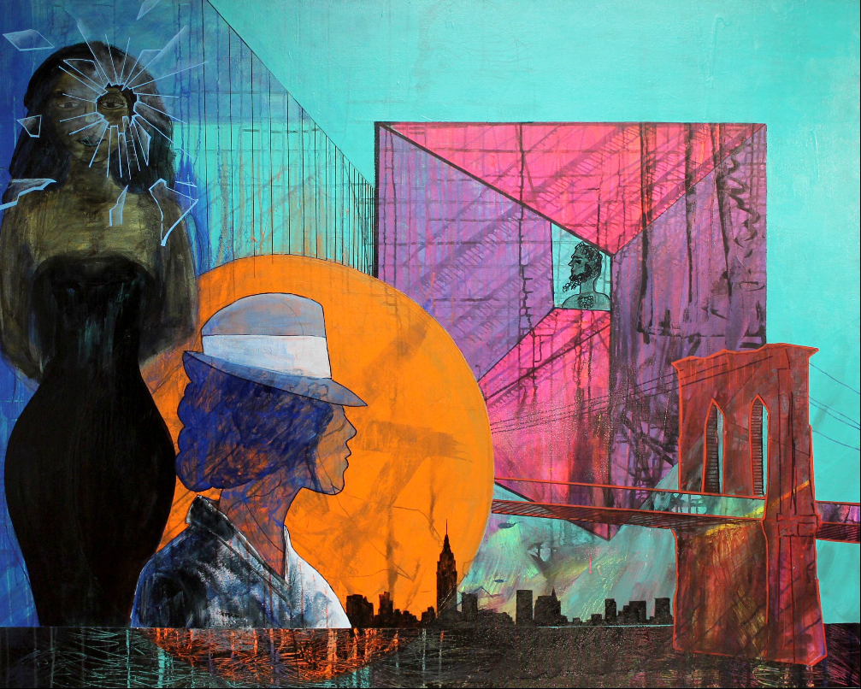
Broken Glass

Randell read the play Broken Glass while he was in an artist residency program in Brooklyn NY. This gave him an authentic backdrop and context to contemplate the characters in Arthur Millers' play.

This painting, "Broken Glass" was made not with a literal interpretation, albeit the Brooklyn NY stage set, the half woman in disguise, the distant little man, the looming dark female peering through the broken glass. Moreover, his intention was to convey a poetic interpretation of the way the play made him feel. The real meat of what Arthur Miller paints is a tragic love story saturated in such a deep fear and longing that makes the heart ache for true love, intimacy, and peace.

Randell Sims studio is on a bluff overlooking the ocean. He Lives with his wife in San Diego, Ca.

http://randellsims.com/

